TASK 3: PROTEIN STRUCTURE PREDICTION
Protein Structure Prediction and Visualization of Hemoglobin Subunit Beta
1. Aim: To predict the three-dimensional structure of a selected protein using SWISS-MODEL and visualize the predicted structure using PyMOL. The structural features of the protein, including its secondary structure and heme group, were also examined.
2. Introduction : Protein structure prediction is an important part of bioinformatics because the three-dimensional structure of a protein provides information about its shape, structural organization, and possible biological function.
In this task, the human Hemoglobin subunit beta (HBB) protein was selected from UniProt. Its three-dimensional structure was predicted using the SWISS-MODEL homology modelling server. The resulting model was then downloaded and visualized using PyMOL.
3. Protein Selected
Feature | Details
Protein name | Hemoglobin subunit beta
UniProt ID | HBB_HUMAN
UniProt Accession | P68871
Organism | Homo sapiens
Protein type | Hemoglobin beta subunit
Hemoglobin subunit beta is a component of hemoglobin and contains a heme prosthetic group. The heme group contains an iron atom that is important for the oxygen-carrying function of hemoglobin.
4. Tools Used
1.UniProt – Used to identify and select the protein sequence.
2.SWISS-MODEL – Used for three-dimensional protein structure prediction.
3.PyMOL – Used to visualize and examine the predicted protein structure.

5. Methodology

Step 1: Protein Selection
The protein Hemoglobin subunit beta (HBB_HUMAN) was selected from UniProt using the accession number P68871.
Step 2: Structure Prediction Using SWISS-MODEL
The selected protein was submitted to the SWISS-MODEL server for structure prediction.
SWISS-MODEL generated a predicted three-dimensional model. The generated project contained Model 01 and used 50 templates for the modelling process.
The important model results obtained were:
- Model: Model 01
- Number of templates: 50
- GMQE: 0.93
- Predicted oligomeric state: Monomer
The GMQE value of 0.93 indicates a high confidence estimate for the generated comparative model.
Step 3: Downloading the Model
The predicted structure from SWISS-MODEL was downloaded and opened in PyMOL for visualization and structural analysis.
Step 4: Visualization in PyMOL
The predicted protein model was loaded into PyMOL and displayed using the cartoon representation.
The protein structure was observed as a compact, predominantly alpha-helical structure. The heme group was also visible within the protein.
The heme group was identified as:
- Residue: HEM
- Residue number: 3
- Central atom: FE (iron)
The heme group was highlighted and a close-up image was generated to clearly show the heme and iron atom.
6. Results
The SWISS-MODEL server successfully generated a three-dimensional model of the selected HBB protein.
The model showed a compact globular structure with predominantly alpha-helical secondary structural elements. In the PyMOL visualization, the protein was displayed in cartoon representation and the heme group was visible separately from the protein backbone.
The heme group was identified inside the structure, with an iron (Fe) atom at its center. A close-up visualization of the heme and Fe atom was also obtained.
SWISS-MODEL Results
Parameter | Result
Protein | HBB_HUMAN
Accession | P68871
Model | Model 01
Templates | 50
GMQE | 0.93
Predicted oligomeric state | Monomer
7. Structural Features Observed
7.1 Alpha-helical structure
The PyMOL cartoon representation showed that the predicted HBB structure is predominantly alpha-helical. The helical regions appear as spiral-shaped structures in the visualization.
7.2 Heme group
A heme prosthetic group was observed within the protein structure. It was displayed in orange in the PyMOL visualization.
7.3 Iron atom
The central iron atom of the heme group was identified as FE. The iron atom was highlighted using a sphere representation for better visualization.
7.4 Compact protein structure
The model showed a compact, globular arrangement of the protein chain with the heme group positioned within the protein structure.
8. PyMOL Images
Figure 1: Overall Predicted Protein Structure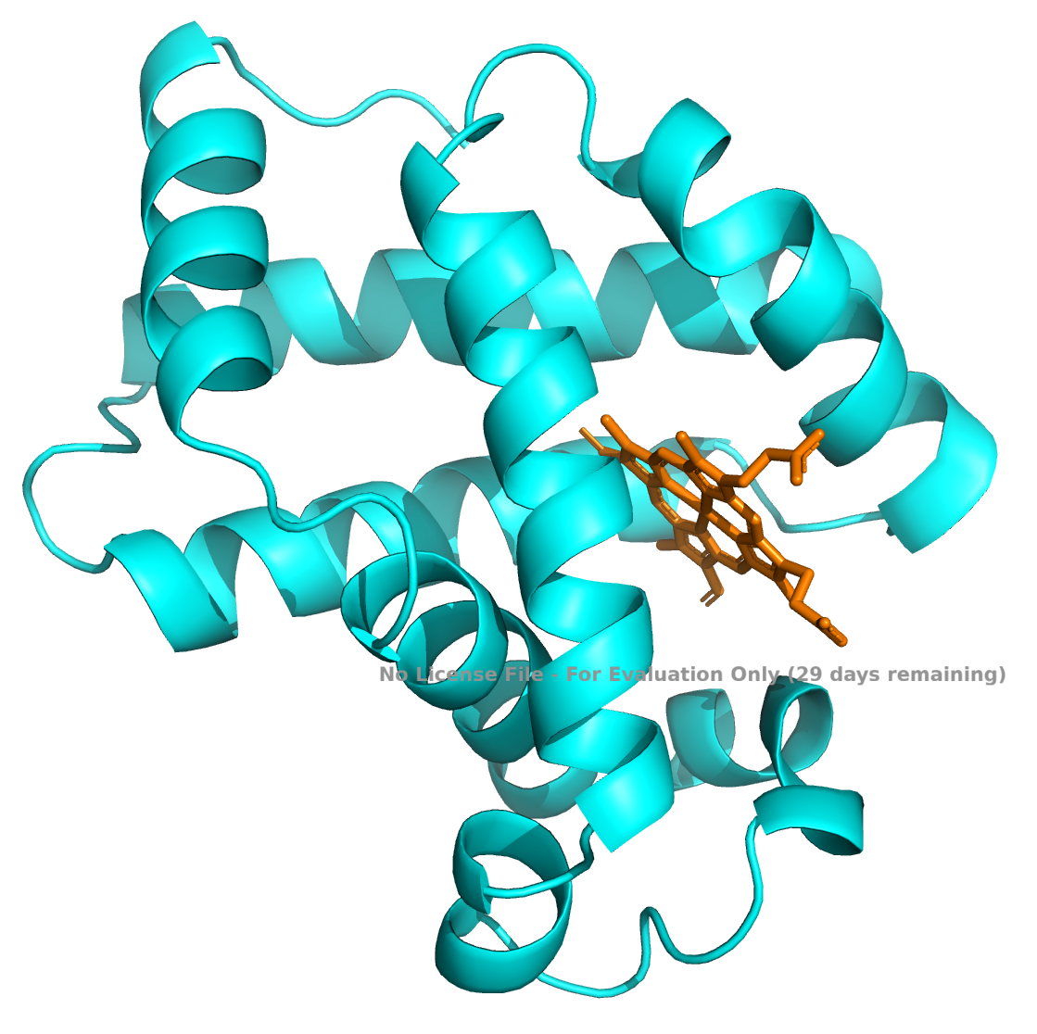

HBB_PyMOL.png
Figure 1. Three-dimensional visualization of the predicted Hemoglobin subunit beta structure using PyMOL. The protein is displayed in cartoon representation and the heme group is visible within the structure.

Figure 2: Heme Group and Iron Atom
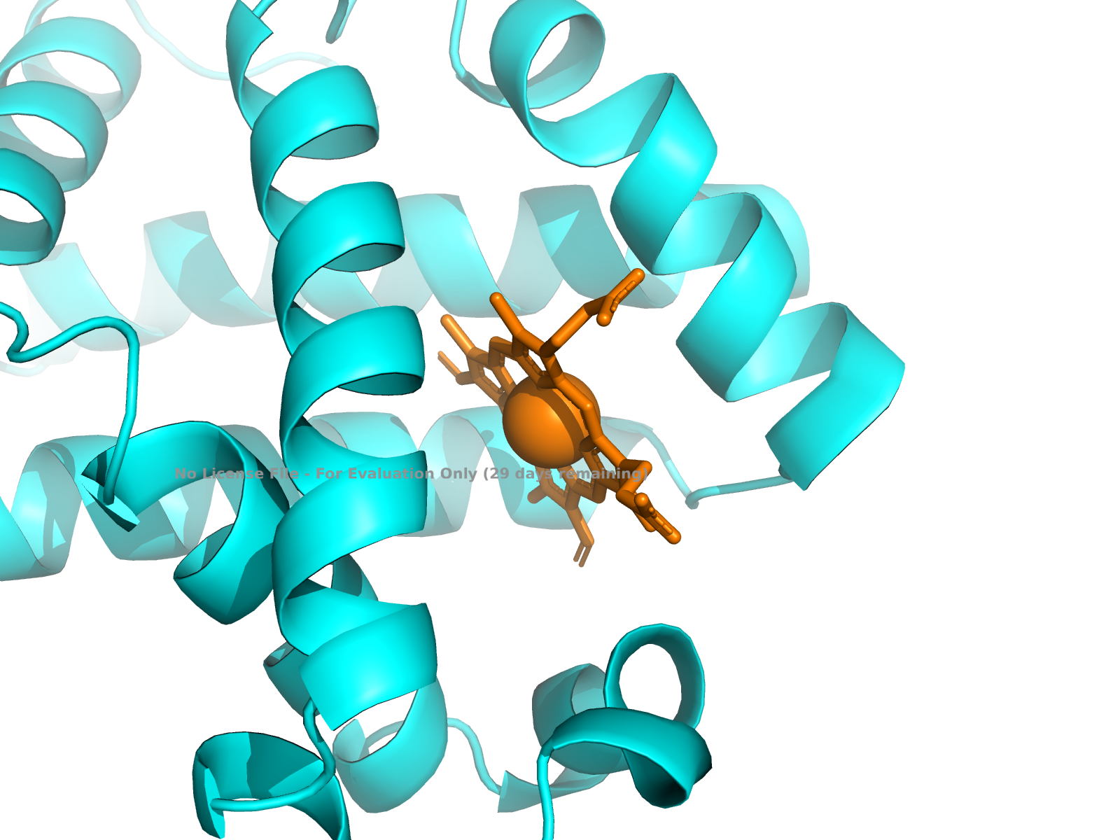
HBB_Heme_Fe_Closeup.png
Figure 2. Close-up visualization of the heme group and its central iron (Fe) atom in the predicted HBB structure.
9. Conclusion
In this task, the three-dimensional structure of human Hemoglobin subunit beta (HBB_HUMAN, P68871) was successfully predicted using SWISS-MODEL and visualized using PyMOL.
The generated SWISS-MODEL prediction contained 50 templates and had a GMQE value of 0.93. The predicted structure showed a predominantly alpha-helical organization. PyMOL visualization also allowed the identification of the heme group and its central iron atom.
This practical demonstrated how bioinformatics tools can be used to predict, visualize, and study the structural characteristics of proteins.
10. Software and Resources Used
- UniProt – Protein sequence and information
- SWISS-MODEL – Protein structure prediction
- PyMOL – Molecular structure visualization

